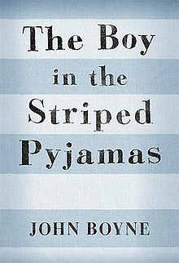 | Name:____________________________  The Boy in Striped Pajamas  Character

A character is a person, or sometimes even an animal, who takes part in the action of a novel or other literary work.
When we are describing characters in a story we usually try to provide some background history, describe what the character looks like, how the character acts, how other people react to this character. We also often include character traits which are descriptive adjectives like happy or sad that tell us the specific qualities of the character. These are the words that we might use to describe ourselves.

Outer character: appearance, age, etc
Inner character: thoughts, feelings, motivation

This is an ongoing activity that we will work on until we complete the novel.
Bruno | Outer Character: | Inner Character:
Character Traits: | Example of or Quote that prove character trait: |  | Pg. #
Schmuel | Outer Character: | Inner Character:
Character Traits: | Example of or Quote that prove character trait: |  | Pg. #

Venn Diagram: Similarities and Differences
Similarities
Schmuel
Bruno

